Archives of Maryland
(Biographical Series)
Donald Gaines Murray (1913-1986)
MSA SC 3520-12494

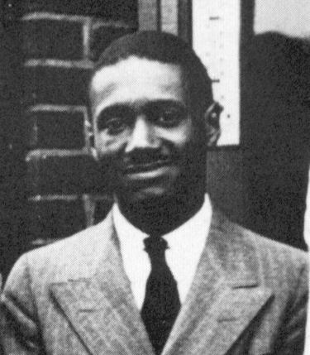
Biography | Images
Sources | Related  Collections

Marshall family photo of Donald Gaines Murray
in Carl T. Rowen, Dream Makers, Dream Breakers:
The World of Justice Thurgood Marshall
(Boston: Little Brown and Company, 1993).
This information resource of the Maryland State Archives is presented here for fair use in the public domain. When this material is used, in whole or in part, proper citation and credit must be attributed to the Maryland State Archives. PLEASE NOTE: Rights assessment for associated source material is the responsibility of the user.

Tell Us What You Think About the Maryland State Archives Website!

[ Archives' Home Page || All About Maryland || Maryland Manual On-Line || Reference & Research
|| Search the Archives || Education & Outreach || Archives of Maryland Online ]
Governor General Assembly Judiciary Maryland.Gov
© Copyright October 27, 2005 Maryland State Archives
Archives of Maryland
(Biographical Series)
Donald Gaines Murray (1913-1986)
MSA SC 3520-12494

Biography:
Born May 24, 1913, in Philadelphia, Pennsylvania. Son of George Lee Murray and Cecilia Lillian Gaines Murray. Attended Douglass High School, graduated 1929; Lincoln College; Amherst College; University of Maryland School of Law, LL.B., 1938. Married Rosa Langley Walker, November 17, 1939; three children: Donald Gaines Murray, Jr., Alfred Walker Gaines, and John Gaines. Last residence was 2016 Bryant Avenue, Baltimore, Maryland, 21217. Died in Baltimore on April 7, 1986, of a heart attack. Buried in Maryland National Cemetery, Baltimore.
Donald Gaines Murray was the subject of the court case University v. Murray, 169 Md. 478 (1936). On April 20, 1935, Murray filed suit in the Baltimore City Court, and petitioned for the issuance of a writ of mandamus that would require he be admitted to the University of Maryland School of Law, a school he had been denied entrance to due to his race. The school had been segregated since 1891, when Dean John Prentiss Poe created a rule segregating the school in response to a public uproar over the graduation of two blacks that year. One of Murray's attorneys was future U.S. Supreme Court justice Thurgood Marshall, who argued that the law school was in violation of the 14th Amendment to the U.S. Constitution. He believed that Murray was denied "separate but equal" treatment because there was no law school in Maryland which admitted African Americans, and therefore, no equal facilities for African Americans to study law in Maryland. The school’s policy had been to provide $200 for qualified black students to attend the closest law school that admitted them, that of Howard University. Judge Eugene O'Dunne agreed that the University of Maryland's policy was unconstitutional and ordered that a mandamus be issued. Lawyers for the University filed an appeal, and Maryland Court of Appeals Judge Carroll T. Bond wrote in the Court's opinion that in order to accommodate Plessy v. Ferguson, Murray could attend the institution, but he had to remain separated from white students. Murray became the first black student to attend the University of Maryland School of Law after the school segregated itself in 1891. Accompanied to campus by Thurgood Marshall, Murray found students willing to sit next to him in class and to study with him.
After graduating from law school, Murray became an investigator for the Baltimore City Housing Authority. During World War II, he served with the army in Europe. Upon his return to Maryland after the War, he became a partner in the firm of Murray, Douglass and Perkins, and worked on many cases involving the NAACP. Later in his life, from 1979 to 1983, he worked as a legal aid. He was an active member of the Baltimore NAACP, the Urban League, the ACLU, the Monumental Bar Association, and the Guardsmen, and was a member of Kappa Alpha Psi fraternity.
Return to Donald Gaines Murray's Introductory Page
This information resource of the Maryland State Archives is presented here for fair use in the public domain. When this material is used, in whole or in part, proper citation and credit must be attributed to the Maryland State Archives. PLEASE NOTE: Rights assessment for associated source material is the responsibility of the user.

Tell Us What You Think About the Maryland State Archives Website!

[ Archives' Home Page || All About Maryland || Maryland Manual On-Line || Reference & Research
|| Search the Archives || Education & Outreach || Archives of Maryland Online ]
Governor General Assembly Judiciary Maryland.Gov
© Copyright October 27, 2005 Maryland State Archives

Archives of Maryland
(Biographical Series)
Donald Gaines Murray (1913-1986)
MSA SC 3520-12494

Sources:

Books -
Davis, Michael D. and Hunter R.. Clark. Thurgood Marshall: Warrior at the Bar, Rebel on the Bench. New York: Birch Lane Press, 1992.
Rowan, Carl T. Dream Makers, Dream Breakers: The World of Justice Thurgood Marshall. Boston: Little, Brown & Co., 1993.
Williams, Juan. Thurgood Marshall: American Revolutionary. New York: Random House, 1998.

Newspaper/journal articles -
Kuebler, Edward J. "Desegregation of the University of Maryland," Maryland Historical Magazine, vol. 71, no. 1, pp. 37-49.
"State Education Ills to Be Aired in Md. Univ. Suit." The Afro-American, 6 (?) May 1935.
"Court Ends Md. U's Color Bar." The Afro-American, Week of 22 June 1935.
"Donald Gaines Murray Sr. dies at 72; sued, entered UM law school in 1935." The Baltimore Sun, 10 April 1986.
“U. of Md. Must Take Negro, Court Says,” Baltimore Sun, 16 January 1936, at 24.
“Colored Students Ruled Out.” N.Y. Times, 10 September 1891.

Maryland State Archives, Documents for the Classroom Series -
University v. Murray, 169 Md. 478 (1936)
From Segregation to Integration: The Donald Murray Case, 1935-1937
Reference Materials prepared for the Consideration of the Commission on the Thurgood Marshall Memorial Statue in Annapolis

Maryland State Archives -
Maryland State Archives DEPARTMENT OF HEALTH AND MENTAL HYGIENE, DIVISION OF VITAL RECORDS (Death Record), MSA T1890, 3/69/2/. (Death certificate incorrectly states birth year as 1923 instead of 1913).
Maryland State Archives SPECIAL COLLECTIONS (Maryland History Slide Collection), MSA SC 1260-129. Photo of Thurgood Marshall, Donald Gaines Murray, and Charles Huston.
Maryland State Archives BALTIMORE CITY COURT (Court Papers) University v. Murray, 169 Md. 478 (1936), MSA C174, 3/32/1/1.
Maryland State Archives SPECIAL COLLECTIONS (Delegate Samuel I. Rosenberg Collection of materials relating to Charles Hamilton Houston and Donald Gaines Murray at Amherst College) MSA SC 5216.

Related web pages -
A Calendar of Maryland's African American History prepared by the staff of the Maryland State Archives' Department of the Study of the Legacy of Slavery in Maryland
Maryland Public Television special "Color at the Bar"

Return to Donald Gaines Murray's Introductory Page
This information resource of the Maryland State Archives is presented here for fair use in the public domain. When this material is used, in whole or in part, proper citation and credit must be attributed to the Maryland State Archives. PLEASE NOTE: Rights assessment for associated source material is the responsibility of the user.

Tell Us What You Think About the Maryland State Archives Website!

[ Archives' Home Page || All About Maryland || Maryland Manual On-Line || Reference & Research
|| Search the Archives || Education & Outreach || Archives of Maryland Online ]
Governor General Assembly Judiciary Maryland.Gov
© Copyright October 27, 2005 Maryland State Archives
Archives of Maryland
(Biographical Series)
Donald Gaines Murray (1913-1986)
MSA SC 3520-12494

Images:
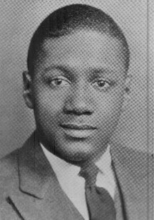  Photo from 1934 Amherst College  yearbook, Archives and Special  Collections, Amherst College Library.  MSA SC 5216. | Marshall family photo of Donald Gaines Murray in Carl T. Rowen, Dream Makers, Dream Breakers: The World of Justice Thurgood Marshall (Boston: Little Brown and Company, 1993).
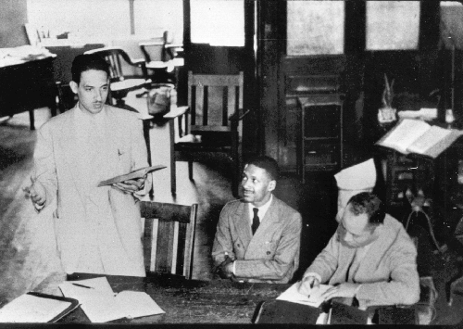
Thurgood Marshall, Donald Gaines Murray and Charles Houston. Maryland History Slide Collection,
MSA SC 1260-129 [D7130b].
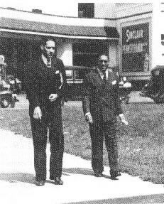
Thurgood Marshall and Donald Gaines Murray
on their way to court to argue for Murray's admission
to the University of Maryland Law School in 1935.
S455-D012164a.tif. From Lucy D. Suddreth,
"Thurgood Marshall: His Papers at LC Document
a Career in Civil Rights," in Library of Congress Information
Bulletin 52, no. 4 (February 22, 1993): 76.
Click here to view S455-D012202A.TIF. Charles Houston, Donald Murray, and Thurgood Marshall in Carl T. Rowen,
Dream Makers, Dream Breakers: The World of Justice Thurgood Marshall. Boston: Little, Brown and Company, 1993.
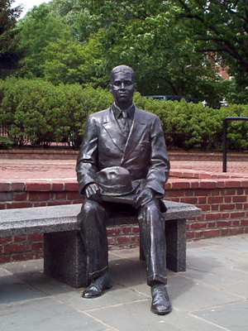  Donald Gaines Murray statue, part of the Thurgood Marshall Memorial  Lawyers Mall, Annapolis. | 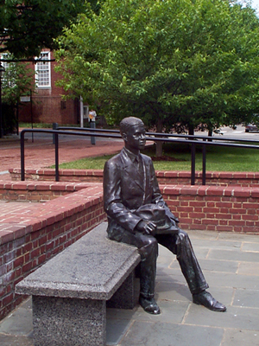  Donald Gaines Murray statue, part of the Thurgood Marshall Memorial  Lawyers Mall, Annapolis .
Return to Donald Gaines Murray's Introductory Page

This information resource of the Maryland State Archives is presented here for fair use in the public domain. When this material is used, in whole or in part, proper citation and credit must be attributed to the Maryland State Archives. PLEASE NOTE: Rights assessment for associated source material is the responsibility of the user.

Tell Us What You Think About the Maryland State Archives Website!

[ Archives' Home Page || All About Maryland || Maryland Manual On-Line || Reference & Research
|| Search the Archives || Education & Outreach || Archives of Maryland Online ]
Governor General Assembly Judiciary Maryland.Gov
© Copyright October 27, 2005 Maryland State Archives
Archives of Maryland
(Biographical Series)
Donald Gaines Murray (1913-1986)
MSA SC 3520-12494

Related Collections:

Maryland State Archives, Documents for the Classroom Series: From Segregation to Integration: The Donald Murray Case, 1935-1937. MSA SC 2221-1-11.
R. Garland Chissell, et al v. Mayor and City Council of Baltimore Papers Collection, MSA SC 5905.

Return to Donald Gaines Murray's Introductory Page
This information resource of the Maryland State Archives is presented here for fair use in the public domain. When this material is used, in whole or in part, proper citation and credit must be attributed to the Maryland State Archives. PLEASE NOTE: Rights assessment for associated source material is the responsibility of the user.

Tell Us What You Think About the Maryland State Archives Website!

[ Archives' Home Page || All About Maryland || Maryland Manual On-Line || Reference & Research
|| Search the Archives || Education & Outreach || Archives of Maryland Online ]
Governor General Assembly Judiciary Maryland.Gov
© Copyright October 27, 2005 Maryland State Archives

